**EXPERIMENT-1**

**Aim:** Write SQL queries to create for various databases using DDL commands (i.e. CREATE, ALTER, DROP, TRUNCATE).

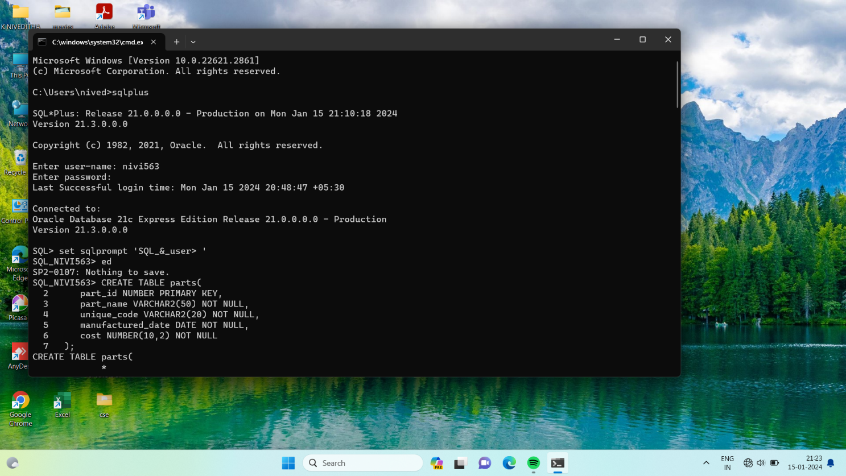

**CREATE TABLE:**

Creates a table with specified constraints.

**Syntax:**

CREATE TABLE tablename (

Column2 data_type[constraint],

PRIMARY KEY (column1[, colunmn2]),

FOREIGN KEY (column1[, column2]) REFERENCES tablename] [, CONSTRAINT constraint]);

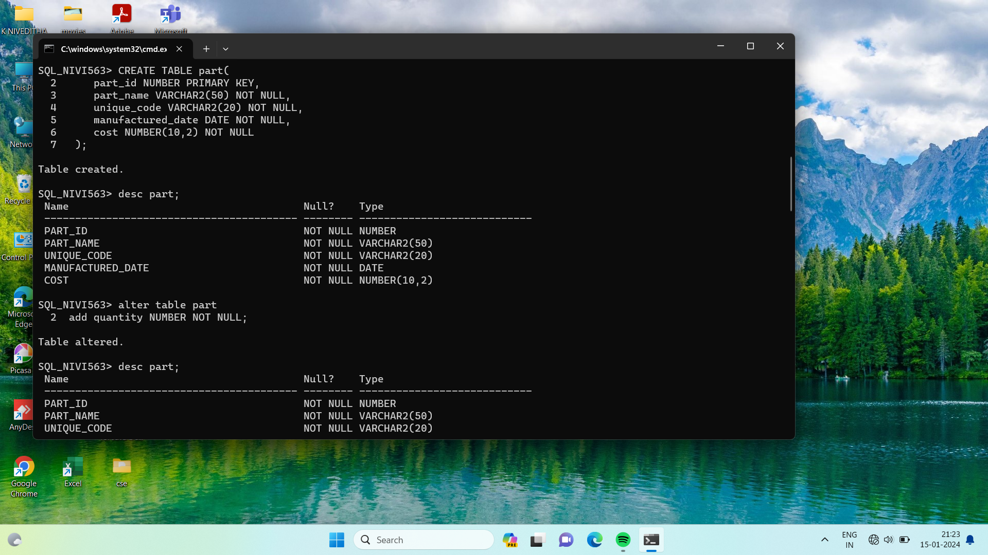



**ALTER TABLE:**

Used to add or modify table details like column names and data types, column constraints.



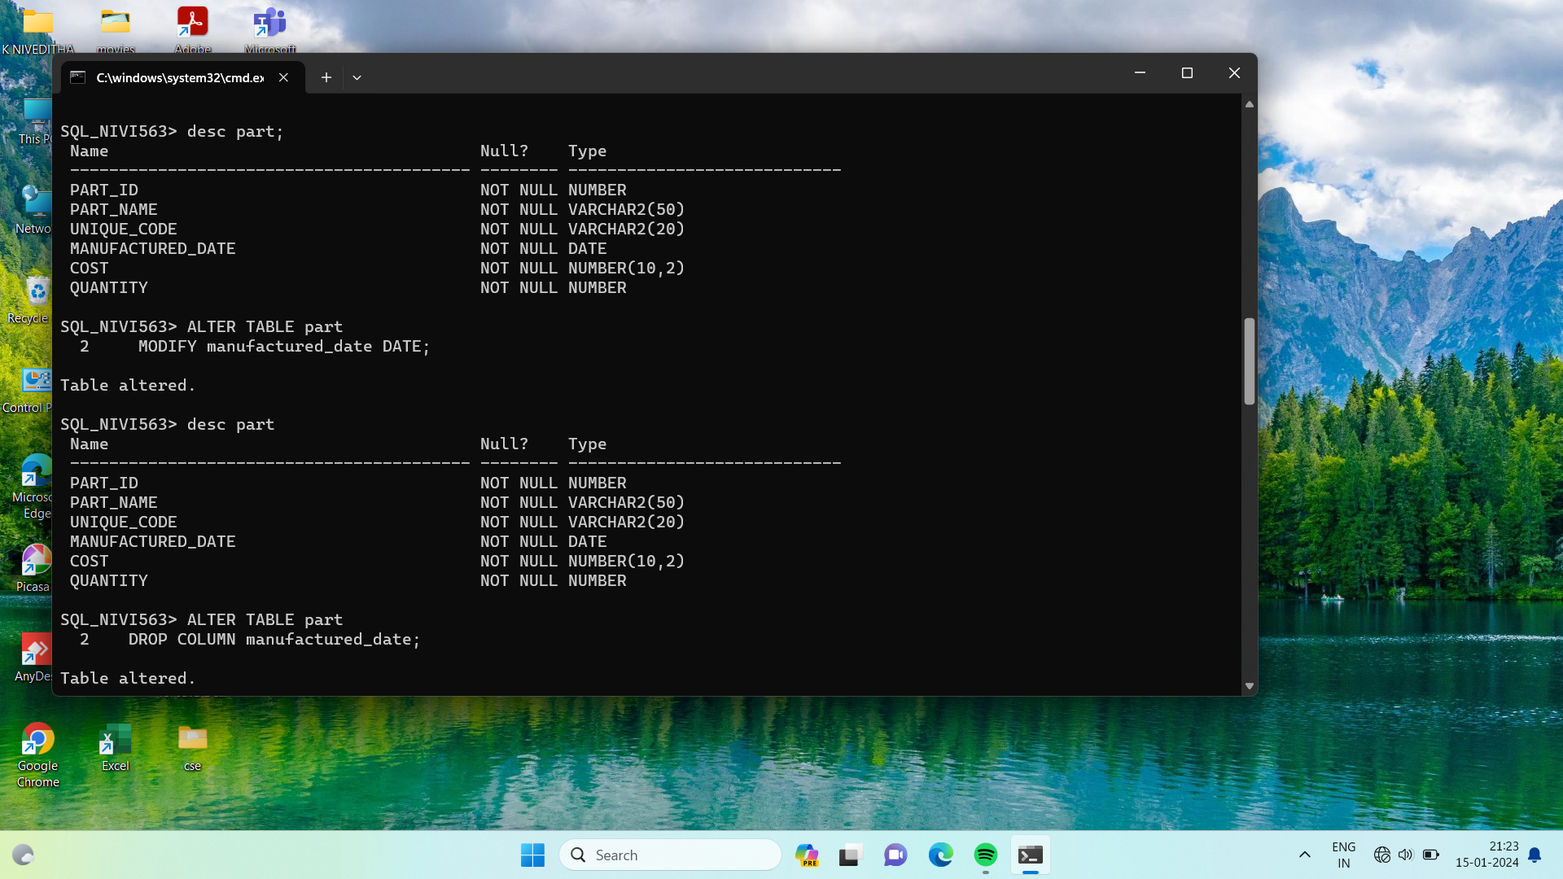

**DROP TABLE:**

Deletes the specified table.

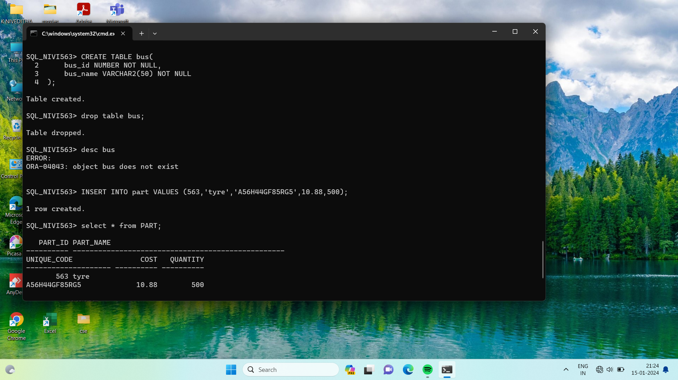

**Syntax:**

DROP TABLE table_name;

**RENAME TABLE:**

To rename table_name, column_name.

**Syntax:**

RENAME new_table_name TO old_table_name;

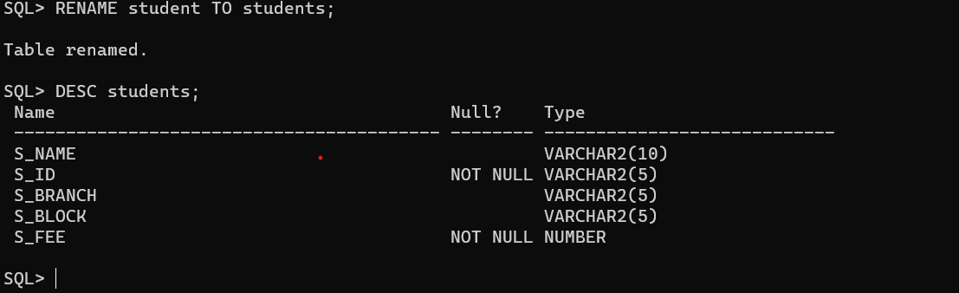

**TRUNCATE TABLE:**

To remove all rows in a specified table.

**Syntax:**

TRUNCATE TABLE table_name;

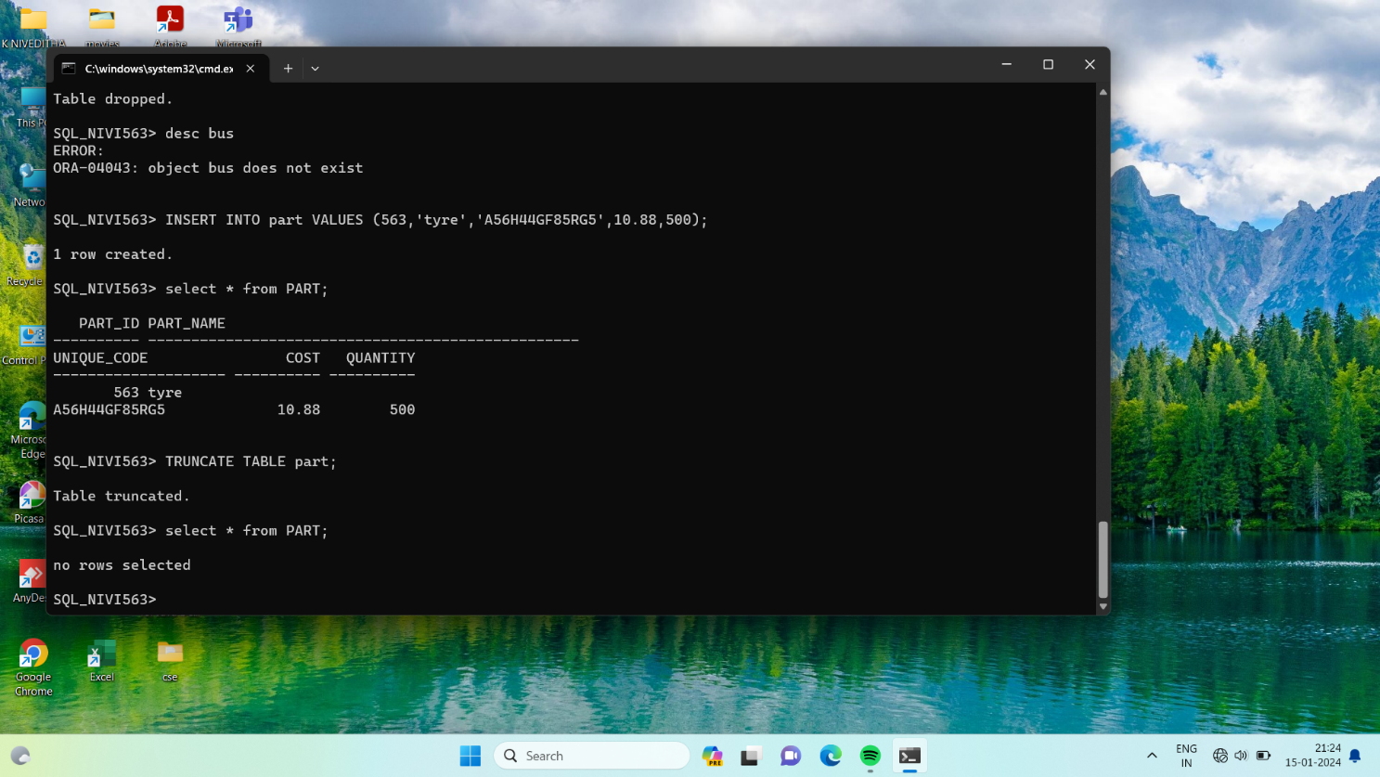

**Conclusion:**

In this lab, we have practiced CREATE, ALTER, DROP, and TRUNCATE commands for the user created table.

**EXPERIMENT-2**

**AIM:** To write SQL queries to MANIPULATE TABLES for c=various databases using DML commands (i.e. INSERT, SELECT, UPDATE, DELETE).

**CREATING TABLE:**

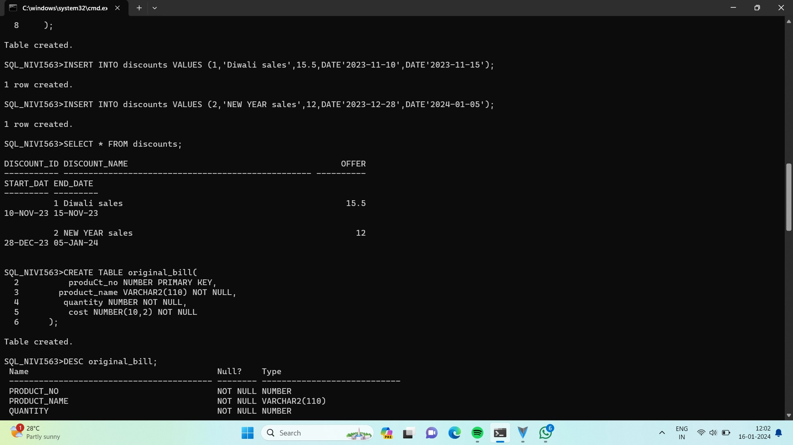

**INSERT COMMAND:**

It is used to add values to a table.

**Syntax:**

INSERT INTO table_name

VALUES (value1, value2, …., valueN);

INSERT INTO table_name (colunm1, colunm2, …., colunmN)

VALUES (value1, value2, ….., valueN);

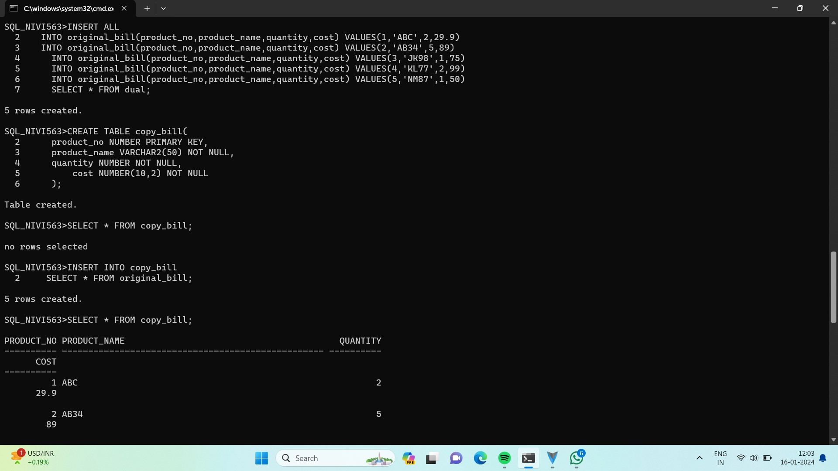

**SELECT COMMAND:**

The SELECT command is used to list the contents of a table.

**Syntax:**

SELECT * FROM table_name:

SELECT column_name FROM table_name;

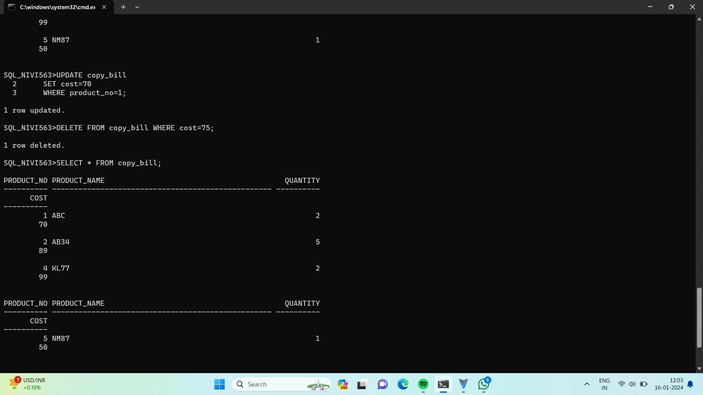

**UPDATE COMMAND:**

The UPDATE command is used to modify the contents of specified table.

**Syntax:**

UPDATE table_name

SET column_name = value [,

Column_name = value]

[WHERE condition_list];

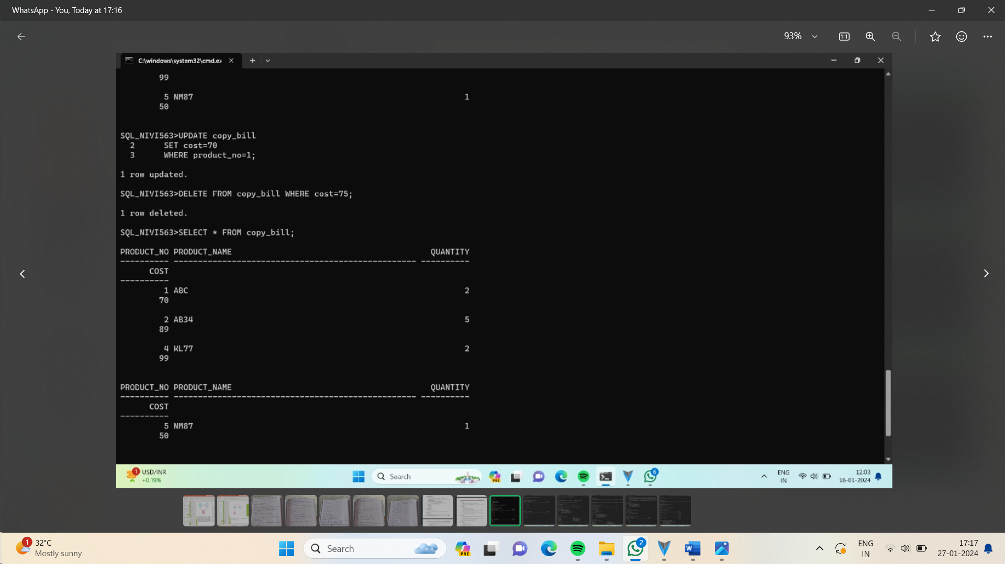

**DELETE COMMAND:**

To delete all rows or specified rows in a table.

**Syntax:**

DELETE FROM table_name [ WHERE condition_list];

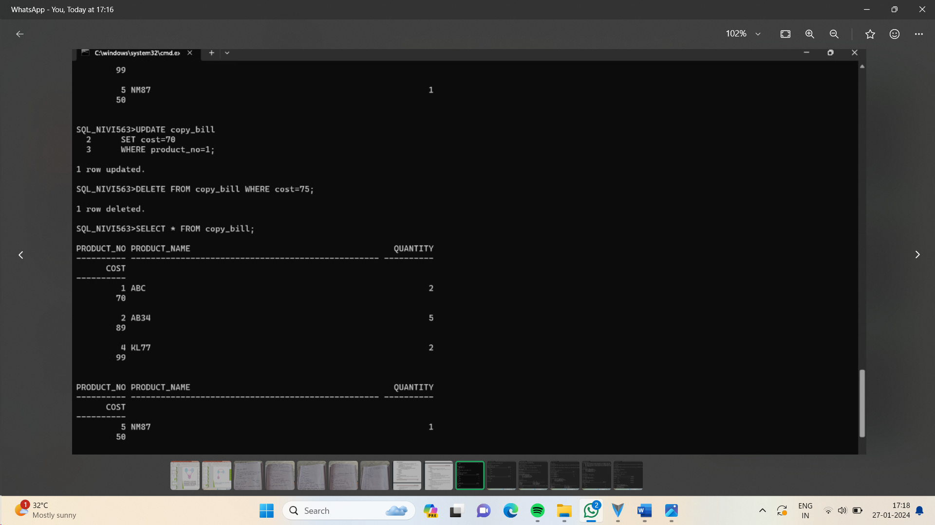

**CONCLUSION:**

In this lab, we have practiced INSERT, SELECT, UPDATE, and DELETE commands for user created table.

**EXPERIMENT-3**

**AIM:** To implement view high level design for various views to CREATE VIEW, ALTER VIEW and DELETE VIEW using DDL commands.

**CREATING TABLE:**

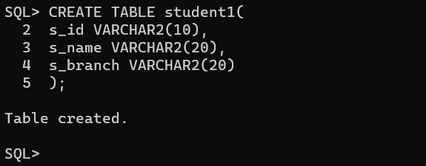

**INSERTING VALUES INTO TABLE student1:**

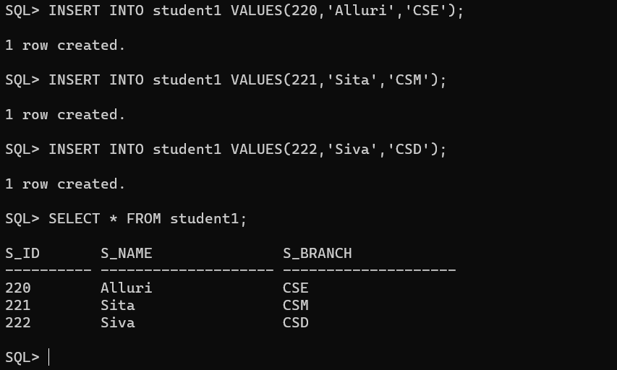

**CREATE VIEW:** Create a view details with attributes s_id and s_name.

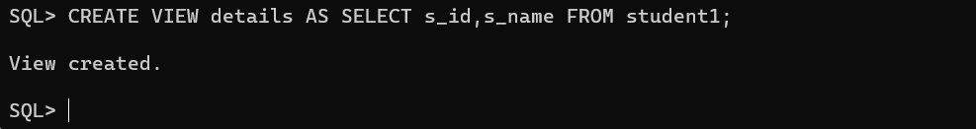

**INSERTING VALUES INTO details view:**

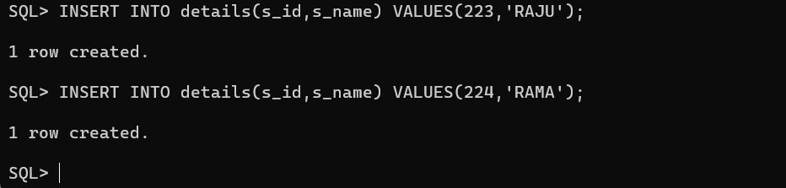

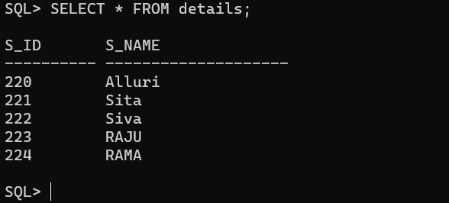

**ALTER VIEW:** Add an attribute branch to the view.

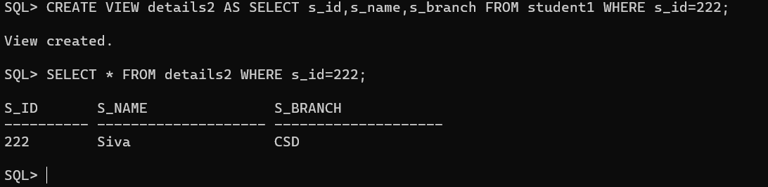

**UPDATE VIEW:** Update the existing name with the new name using UPDATE command.

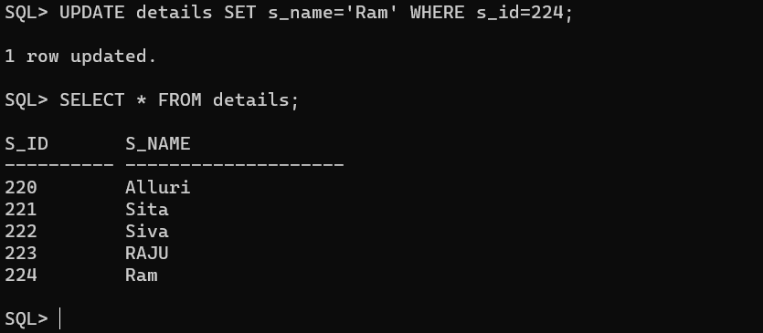

**DROP VIEW:** Drop a view using DROP command.

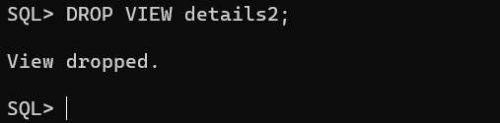

**Conclusion:**

In this lab, we have practiced how to CREATE VIEW, ALTER VIEW, UPDATE VIEW, and DELETE VIEW for user created table.

**EXPERIMENT-4**

**AIM:** To implement SQL queries for set operations like UNION, UNION ALL, INTERSECT, INTERSECT ALL, MINUS, CROSS JOIN, NATURAL JOIN.

**CREATING A TABLE instructor2:**

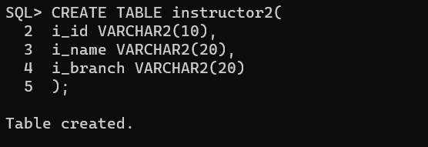

**INSERTING VALUES INTO TABLE instructor2:**

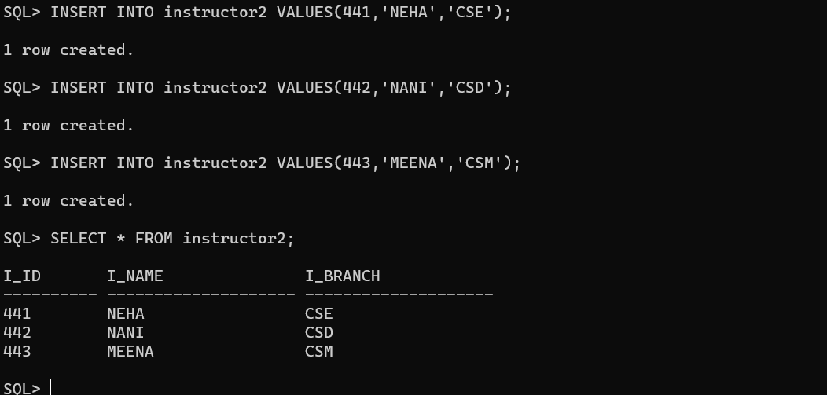

**CREATING TABLE department:**

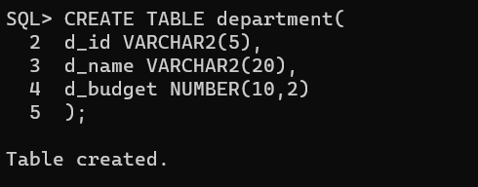

**INSERTING VALUES INTO department:**

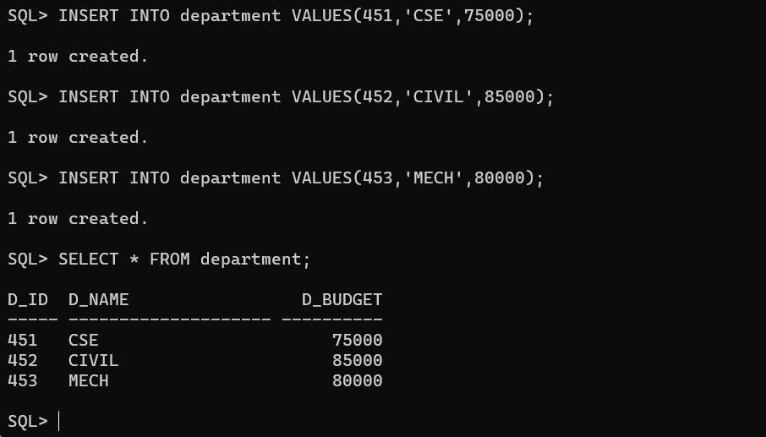

**UNION:** The attributes i_branch from instructor2 and d_name from department are joined using UNION command.

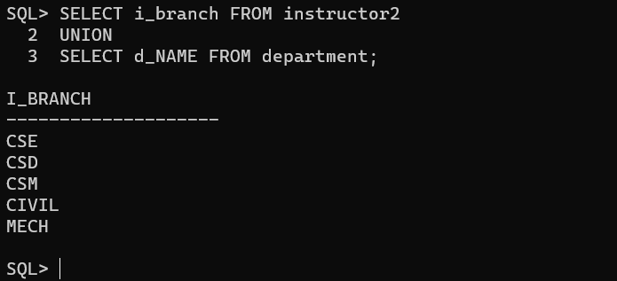

**UNION ALL:** The attributes i_branch from instructor2 and d_name from department are joined along with duplicates using UNION ALL command.

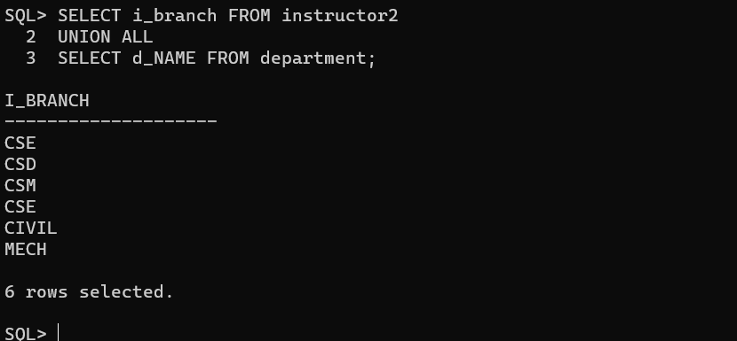

**INTERSECT:** Displays similar values in two or more attributes from department and instructor4 using INTERSECT command.

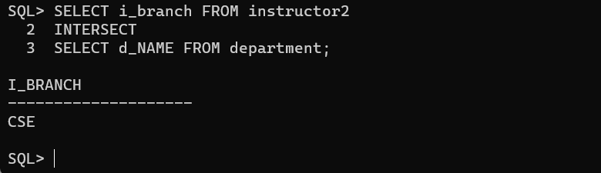

**MINUS:** It eliminates the same values of second column from the first column and represents the remaining values using command MINUS.

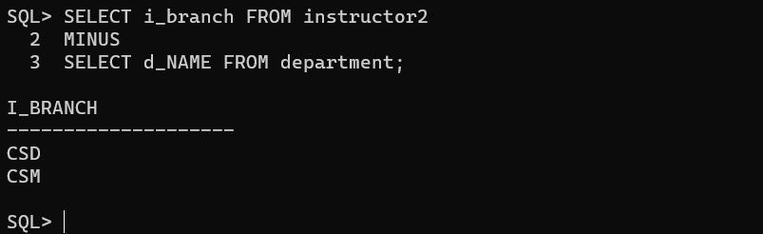

**CROSS JOIN:** Its cross products the all the attributes using CROSS JOIN command.

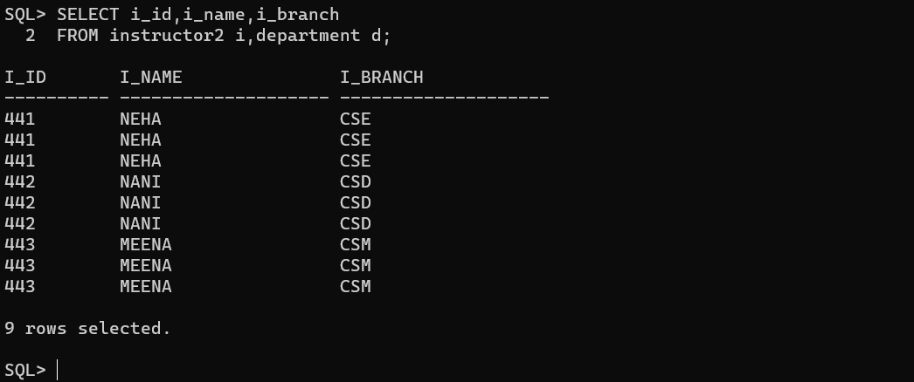

**Conclusion:**

In this lab, we have practiced the set operations like UNION, UNION ALL, INTERSECT, MINUS, CROSS JOIN on user created tables.

**EXPERIMENT-5**

**AIM:**SQL queries to perform SPECIAL OPERATIONS (IS NULL, BETWEEN, LIKE, IN, EXISTS).

**CREATING TABLE-1:**

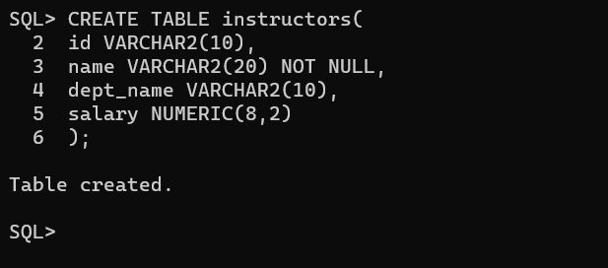

**INSERTING VALUES INTO THE TABLE:**

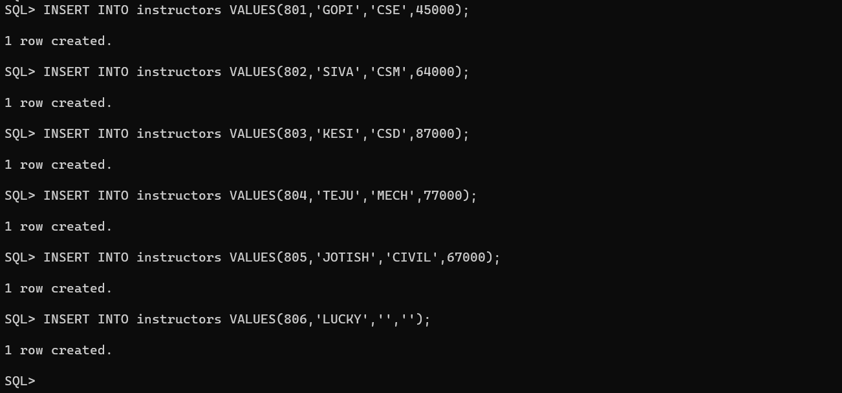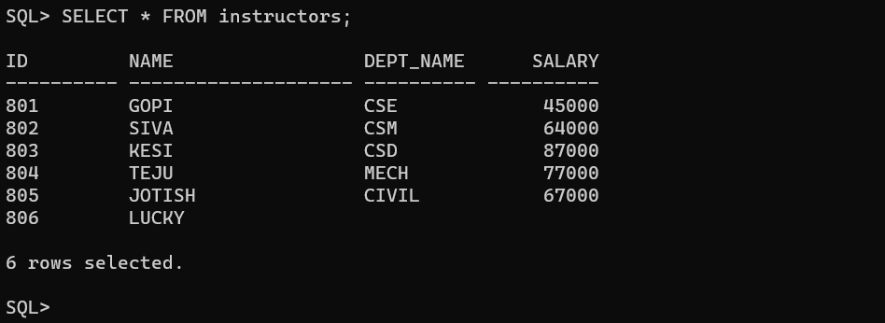

**IS NULL:** It is used to check null values and display null attributes. It displays attributes that have null values.

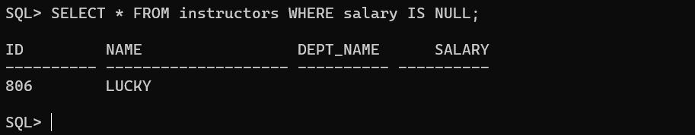

This command displays the salary that are not equal to 64000.

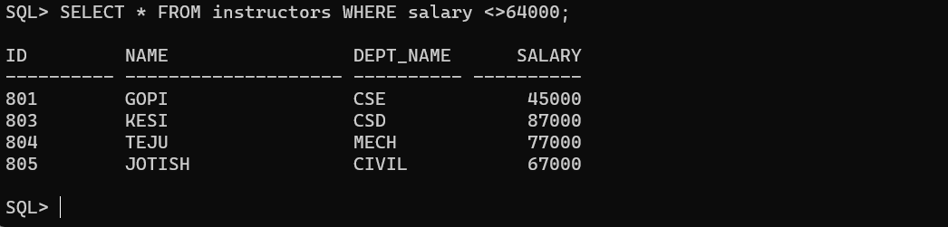

**IS NOT NULL:** It displays attributes that don’t have null values.

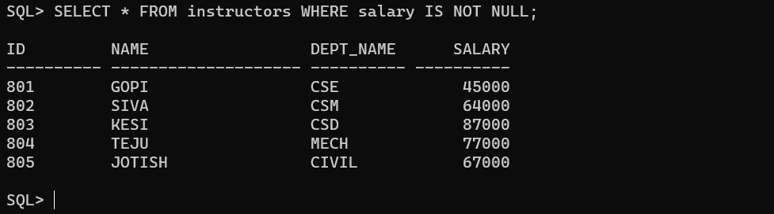

**BETWEEN:** This is used to check range of values.

By following command, it displays all the attributes between 45000 and 77000.

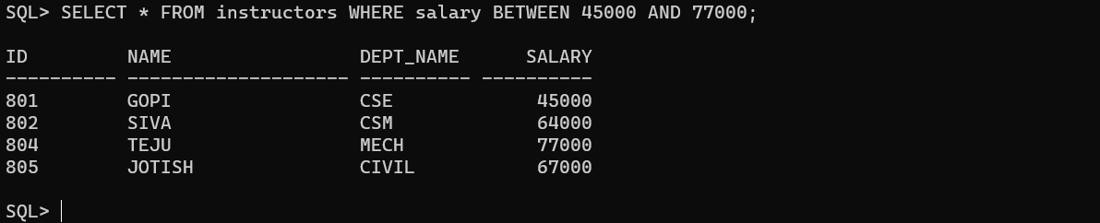

The following command displays salary that are not in between 45000 and 77000.

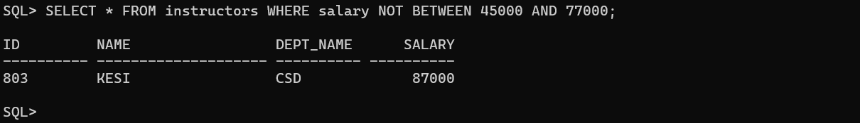

**IN:** This is used to check a member is in a set or not. It displays if the id’s are present in the table.

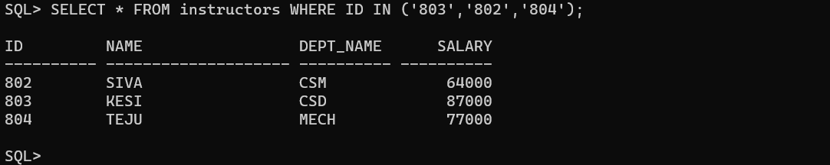

The following command displays all the attributes with id’s except the given id’s.

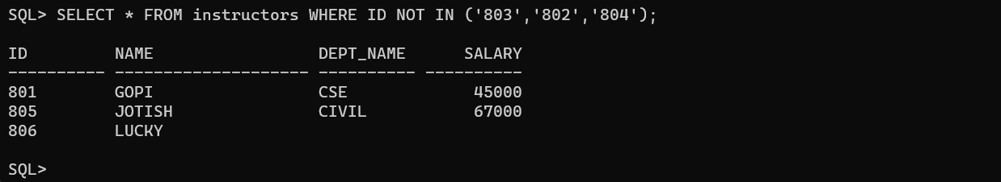

**EXISTS:** This is used to check whether given set is empty or not. It displays null attributes that are null according to the given condition.

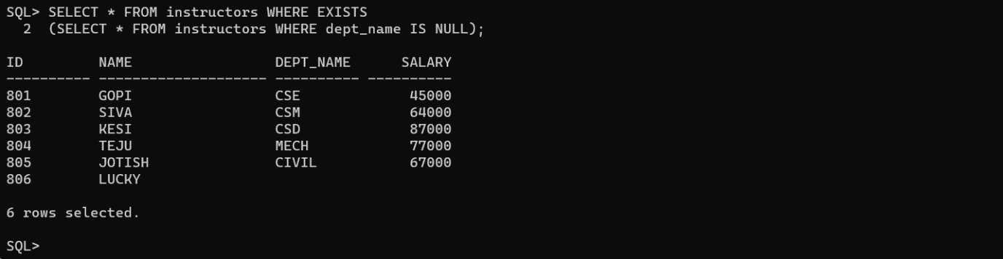

**LIKE:** This is used to check given string is present or not. It displays all the attributes that start with character ‘c’.

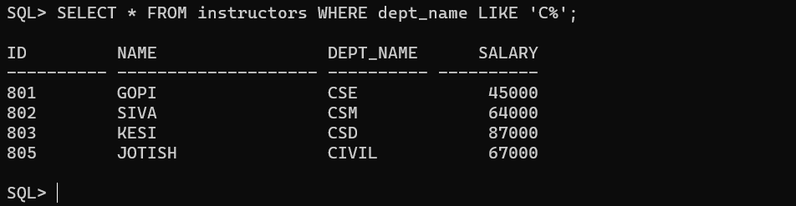

**Conclusion:** In this lab, we have practiced SPECIAL OPERATIONS IS NULL, BETWEEN, LIKE, IN, EXISTS on user created table.

**EXPERIMENT-6**

AIM: To implement SQL queries to perform JOIN OPERATIONS (CONDITIONAL JOIN, EQUI JOIN, LEFT OUTER JOIN, RIGHT OUTER JOIN, FULL OUTER JOIN).

CREATING TABLE-1:

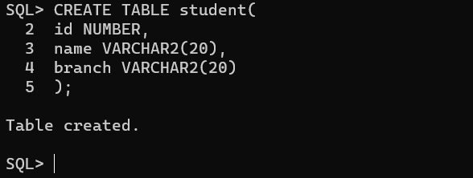

INSERTING VALUES INTO THE TABLE:

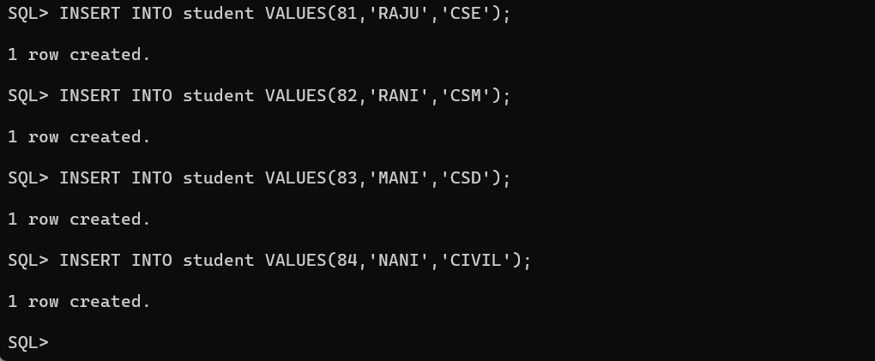

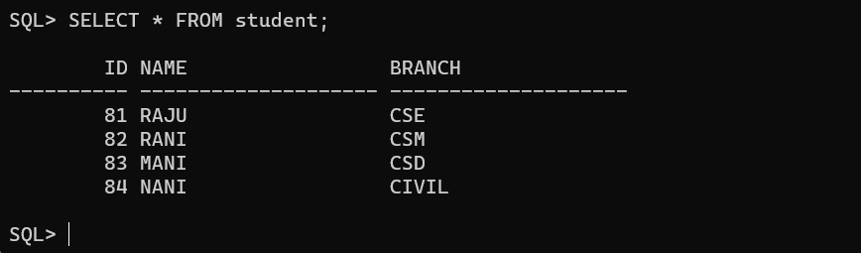

CREATING TABLE-2:

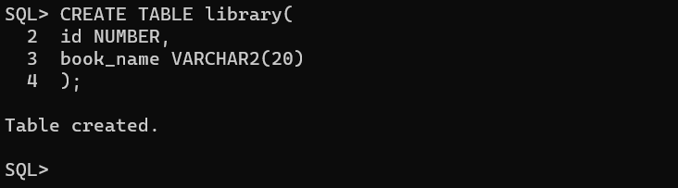

INSERTING VALUES INTO TABLE-2:

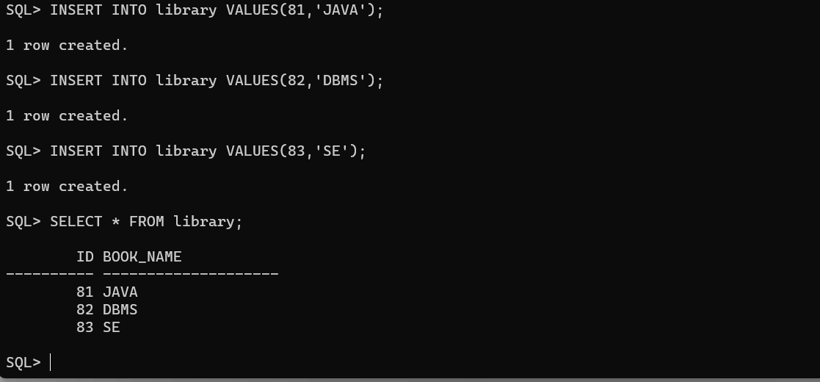

CONDITIONAL JOIN: It helps in retrieving the desired data and performing complex queries.

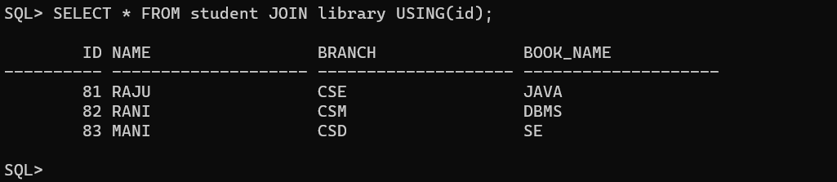

EQUI JOIN: It helps in retrieving related information from different tables by matching corresponding values.



LEFT OUTER JOIN: It combines data from two or more tables based on the matching values in specified columns, but it also includes unmatched rows from the left table.

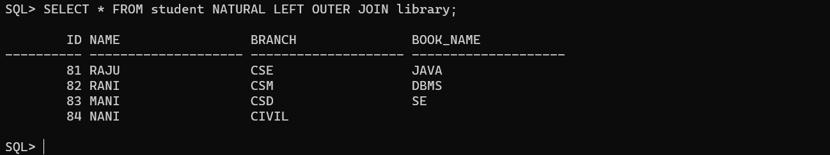

RIGHT OUTER JOIN: It combines data from two or more tables based on the matching values in specified columns, but also includes unmatched rows from he right table.

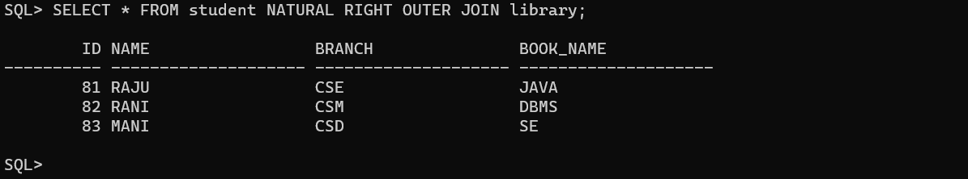

FULL OUTER JOIN: It includes all the rows from both the left and right tables, even if there is no match.

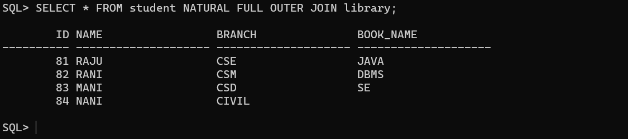

Conclusion: In this lab, we have practiced JOIN OPERATIONS CONDITIONAL JOIN, EQUI JOIN, LEFT OUTER JOIN, RIGHT OUTER JOIN, FULL OUTER JOIN on user created tables.

**EXPERIMENT-7**

**AIM:** To implement SQL queries to perform AGGREGATE OPERATIONS (SUM, COUNT, AVG, MIN, MAX).

**CREATING A TABLE:**

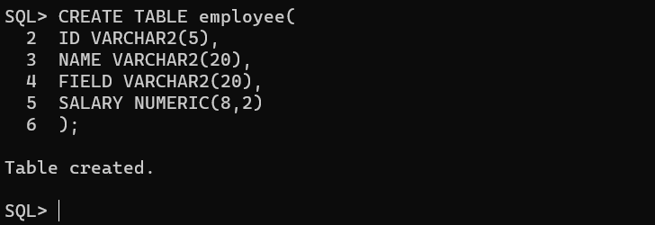

**INSERTING VALUES INTO TABLE:**

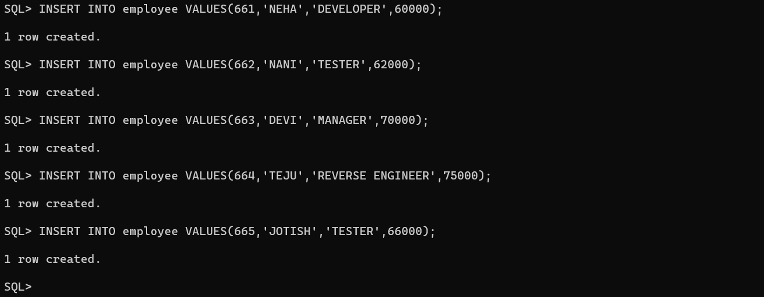

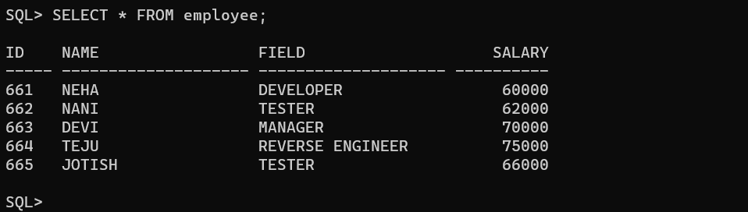

**COUNT:** It displays the count on members present in employee.

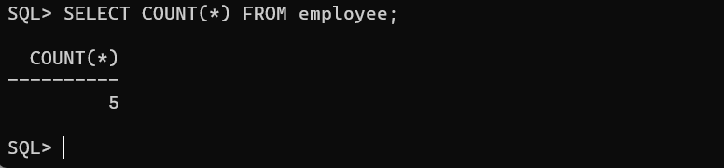

**AVERAGE(AVG):** It displays average salary of each employee.

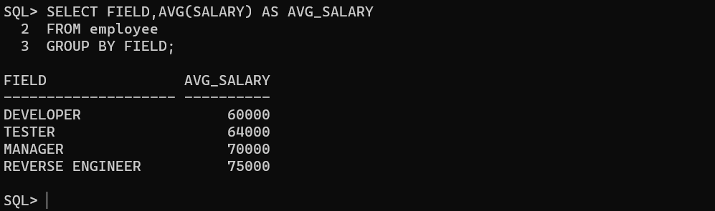

**SUM:** It displays sum of all the salaries from the table.

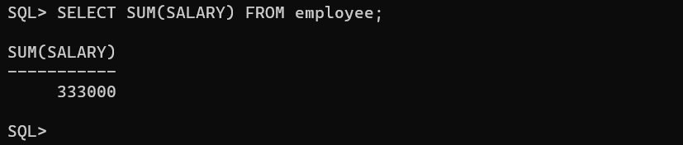

**MIN:** It displays the minimum salary from the table.

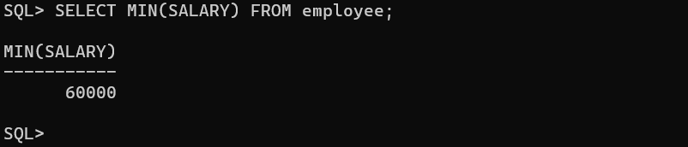

**MAX:** It displays the maximum salary from the table.

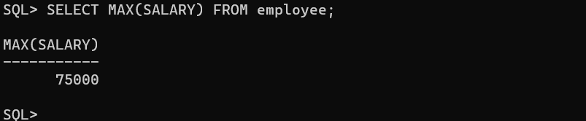

**Conclusion:** In this lab, we have practiced AGGREGATE OPERATIONS like SUM, COUNT, AVERAGE, MIN, MAX on user created table.

**EXPERIMENT-8**

**AIM:** To implement SQL queries to perform BUILT-IN FUNCTIONS (DATE, TIME).

**CASE CONVERSION:**

**LOWER ():** It converts a string into lowercase.

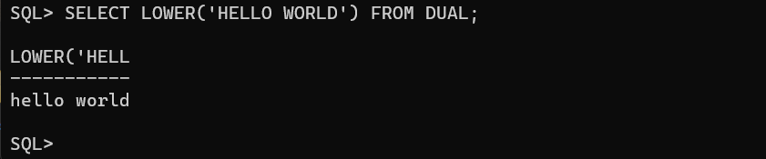

**UPPER ():** It converts a string into uppercase.

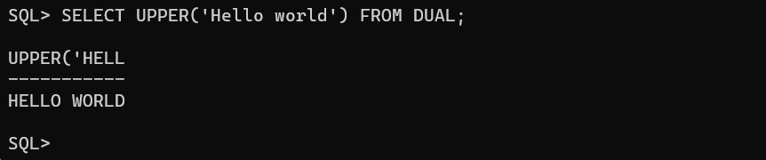

**INITCAP ():** It converts a string into camel case.

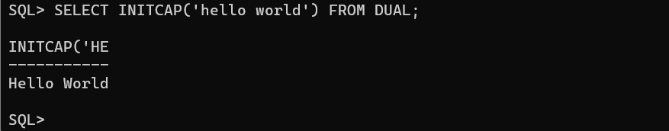

**CONCAT ():** It adds two or more expressions together.

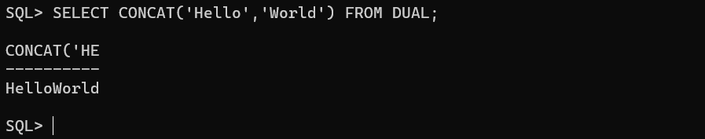

**SUBSTR ():** It extracts a substring from a string.

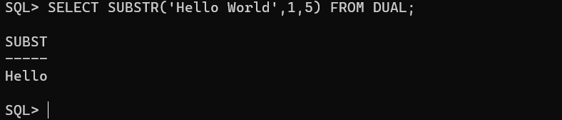

**LENGTH ():** It returns the length of the given string.

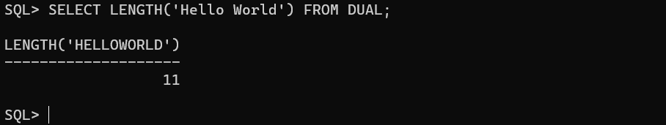

**INSTR ():** It returns the position or the first occurrence of a string in another string.

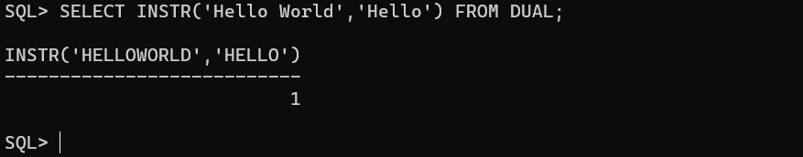

**TRIM ():** It removes the selected one from string.

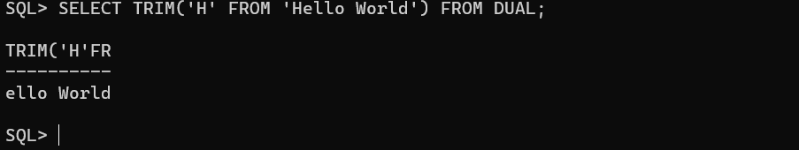

**NUMBER FUNCTIONS:**

**ROUND ():** It returns the specified values.

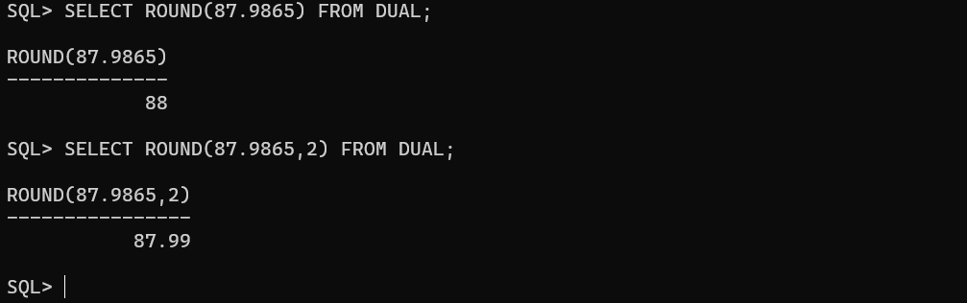

**TRUNCATE ():** It removes the decimal values which are specified.

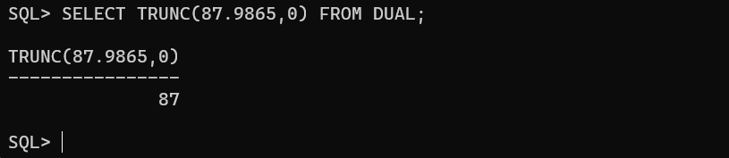

**MOD ():** It returns the remainder.

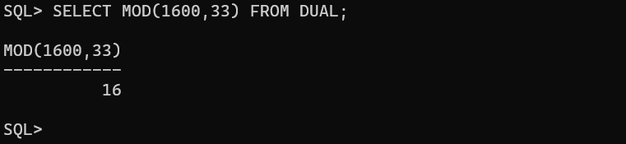

**DATE FUNCTIONS:**

**SYSDATE ():**

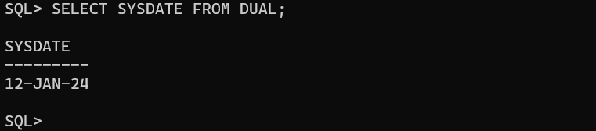

**MONTHS_BETWEEN ():**

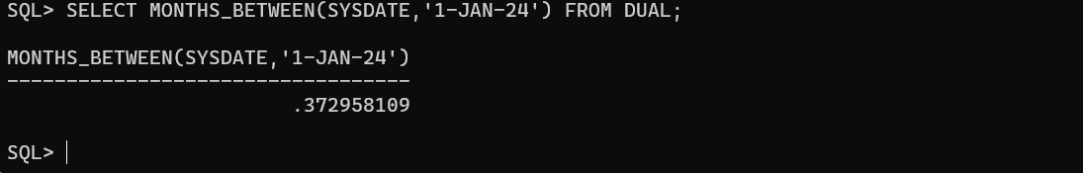

**ADD_MONTHS ():**

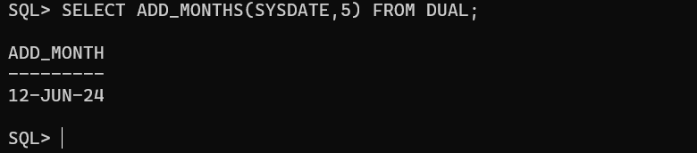

**NEXT_DAY ():**

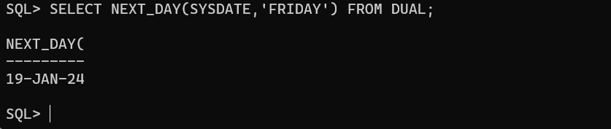

**LAST_DAY ():**

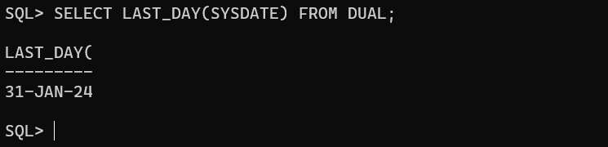

**TRUNC ():**

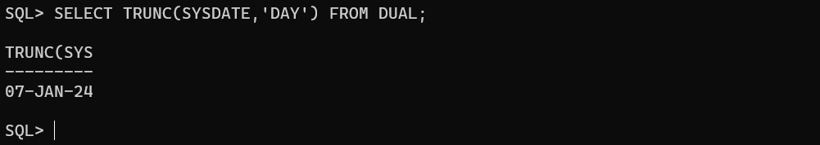

**Conclusion:** In this lab, we have practiced BUILT-IN FUNCTIONS like DATE AND TIME .

**EXPERIMENT-9**

**AIM:** To implement SQL queries to perform KEY CONSTRAINTS (PRIMARY KEY, FOREIGN KEY, UNIQUE, NOT NULL, CHECK, DEFAULT).

**PRIMARY KEY:** A primary key is a field which can uniquely identify each row in table and this constraint is used to specify a field as primary key.

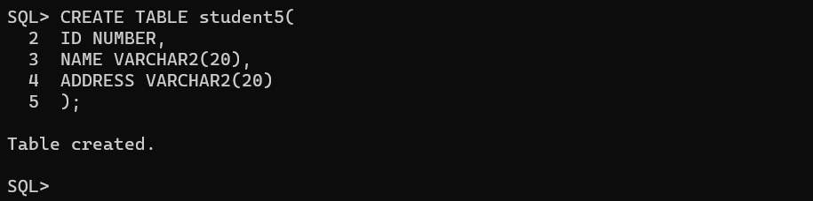

**FOREIGN KEY:** A foreign key is a field which can uniquely each row in another table.

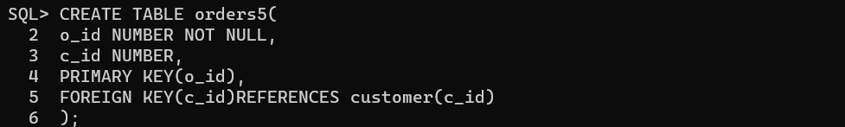



**UNIQUE:** This constraint when specified with a column, tells that the values in the column must be unique i.e., the values in any row of a column must not be repeated.

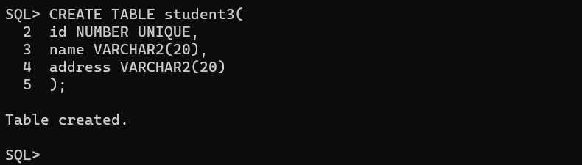

**NOT NULL:** This constraint tells that we cannot store a null value in a column.

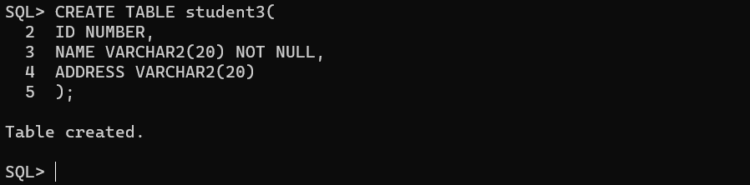

**DEFAULT:** This constraint specifies a default value for the column when no value is specified by the user.

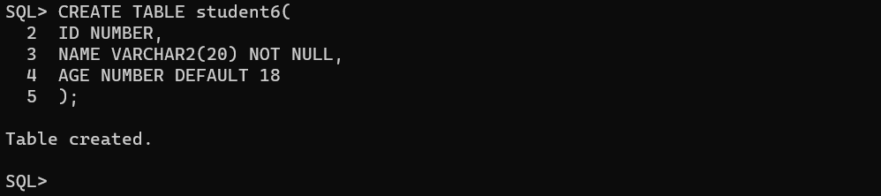

**CHECK:** This constraint helps to validate the value for the column to meet a particular condition i.e. it helps to ensure that the value stored in a column meets a specific condition.

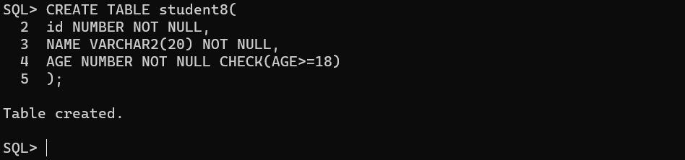

**Conclusion:** In this lab, we have practiced KEY CONSTRAINTS PRIMARY KEY, FOREIGN KEY, UNIQUE, NOT NULL, CHECK, DEFAULT on user created tables.

**EXPERIMENT-10**

**AIM:** To write a PL/SQL program for calculating the factorial of a given number.

PROCEDURE :

LOGIN INTO SQLPLUS

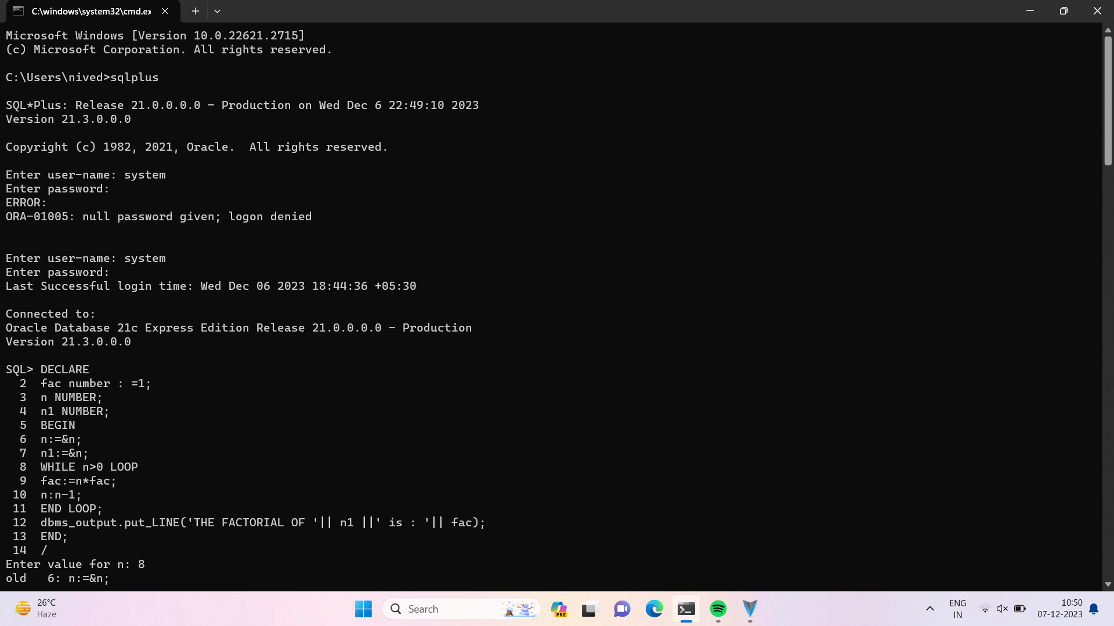

PROGRAM CODE :

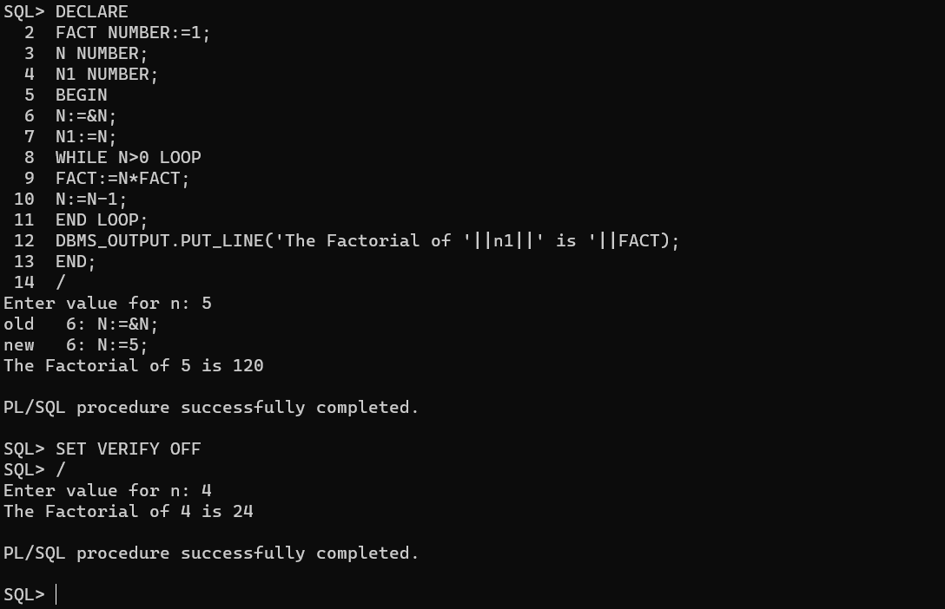

HOW TO RUN THE PROGRAM :

* RUN THE PROGRAM USE TO ‘/ ‘ COMMAND
* BEFORE THE EXECUTION ,”SET SERVEROUT ON “

Command for the purpose of execution.

* To eliminate debugging message the following command should be used i.e “SET VERIFY OFF

**Conclusion:** In this lab, we have practiced a PL/SQL program for displaying FFACTORIAL of a given interger.

EXPERIMENT-11

**Q** WRITE A PL/SQL PROGRAM FOR FINDING THE GIVEN NUMBER IS PRIME OR NOT.

AIM: TO WRITE A PROGRAM FOR FINDING THE GIVEN NUMBER IS PRIME OR NOT

PROGRAM DESCRIPTION: THE PROGRAM TAKES INPUT FROM THE USER AND CHECKS WETHER THE GIVEN NUMBER IS PRIMEOR NOT.

PROCEDURE : LOGIN INTO SQLPLUS



PROGRAM CODE :

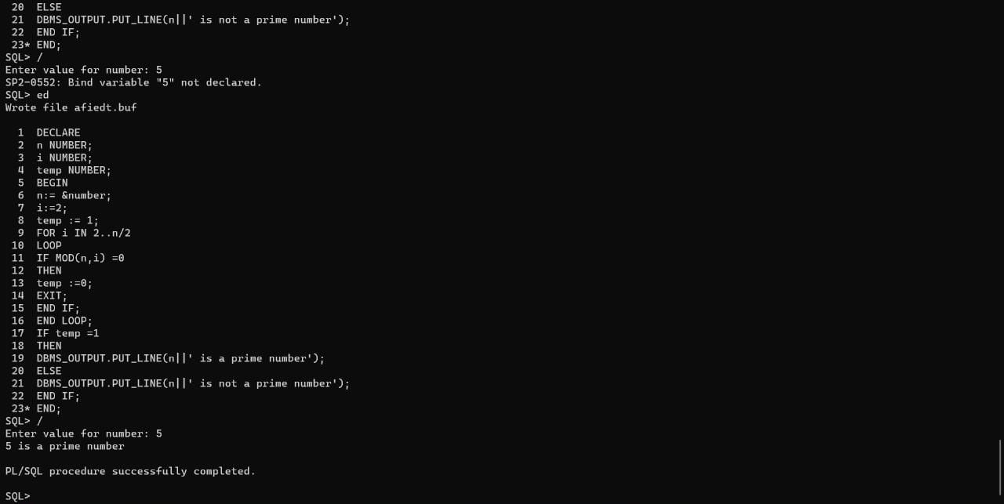

HOW TO RUN THE PROGRAM :

* RUN THE PROGRAM USE TO ‘/ ‘ COMMAND
* BEFORE THE EXECUTION ,”SET SERVEROUT ON “

Command for the purpose of execution.

* To eliminate debugging message the following command should be used i.e “SET VERIFY OFF

Output :

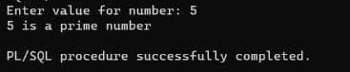

Conclusion : Therefore pl/sql procedure is executed succesfully

**EXPERIMENT-12**

**AIM:** To write a PL/SQL program for displaying the Fibonacci series up to an integer.

**SOURCE CODE & OUTPUT:**

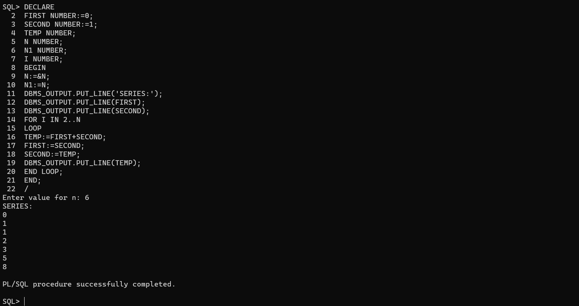

HOW TO RUN THE PROGRAM :

* RUN THE PROGRAM USE TO ‘/ ‘ COMMAND
* BEFORE THE EXECUTION ,”SET SERVEROUT ON “

Command for the purpose of execution.

* To eliminate debugging message the following command should be used i.e “SET VERIFY OFF

**Conclusion:** In this lab, we have practiced a PL/SQL program for displaying Fibonacci series up to an integer.

**EXPERIMENT-13**

**AIM:** To write a PL/SQL program to implement Stored Procedure on table.

**PL/SQL Procedure:**

The PL/SQL stored procedure or simply a procedure is a PL/SQL block which performs one or more specific tasks. It is just like procedures in other programming languages.

The procedure contains a header and a body.

**EXAMPLE-1:**

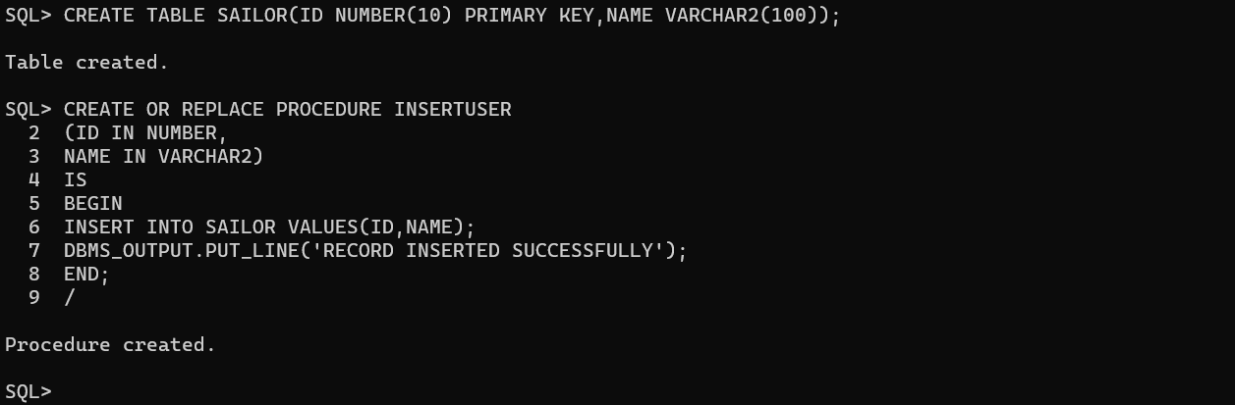

**EXECUTION PROCEDURE:**

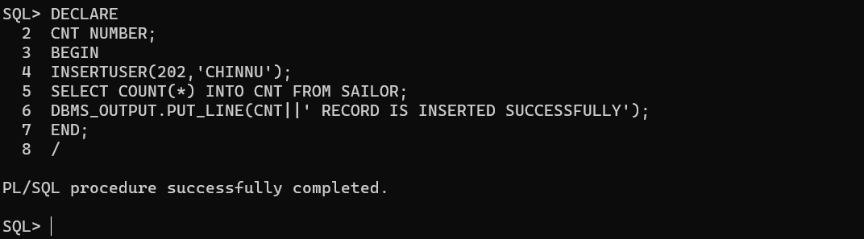

**DROP PROCEDURE:**

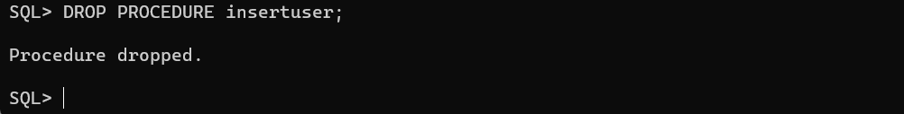

**Conclusion:** In this lab, we have practiced a PL/SQL program to implement Stored Procedure on table.

EXPERIMENT-14

Q. WRITE A PL/SQL PROGRAM TO IMPLEMENT STORED FUNCTION ON TABLE.

AIM: TO WRITE A PL/SQL PROGRAM TO IMPLEMENT STORED FUNCTION ON TABLE.

PROGRAM DESCRIPTION: THE PL/SQL FUNCTION IS VERY SIMILAR TO PL/SQL PROCEDURE.THE MAIN DIFFERENCE BETWEEN PROCEDURE AND A FUNCTION IS A FUNCTION MUST ALWAYS RETURN A VALUE, AND ON OTHER HAND A PROCEDURE MAY OR MAY NOT RETURN A VALUE.

PROCEDURE : LOGIN INTO SQLPLUS



PROGRAM CODE :

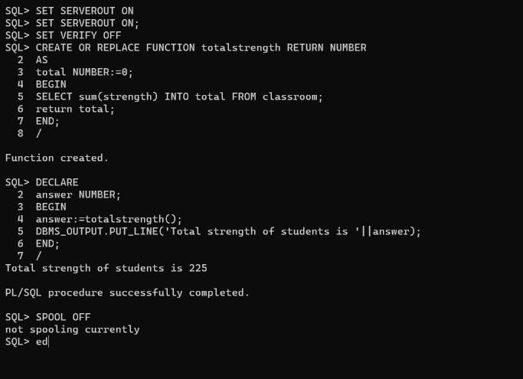

HOW TO RUN THE PROGRAM :

* RUN THE PROGRAM USE TO ‘/ ‘ COMMAND
* BEFORE THE EXECUTION ,”SET SERVEROUT ON “

Command for the purpose of execution.

* To eliminate debugging message the following command should be used i.e “SET VERIFY OFF

Output :

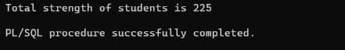

Conclusion : Therefore pl/sql procedure is executed succesfully

**EXPERIMENT-15**

**AIM:** To write PL/SQL program to implement Trigger on table.

**Tigger:**

Trigger is invoked by Oracle engine automatically whenever a specified event occurs. Trigger is stored into database and invoked repeatedly, when specific condition match. Triggers are stored programs, which are automatically executed or fired when some event occurs. Triggers are written to be executed in response to any of the following events.

A database manipulation (DML) statement (DELETE, INSERT, UPDATE).

A database definition (DDL) statement (CREATE, ALTER, DROP).

A database operation (SERVERERROR, LOGON, LOGOFF, STARTUP, SHUTDOWN).

**CREATING A TABLE:**

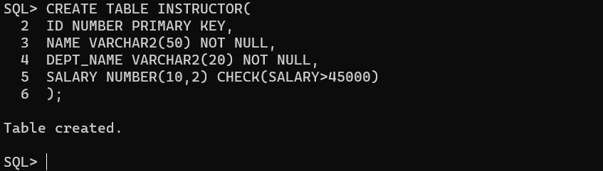

**INSERTING VALUES INTO THE TABLE:**



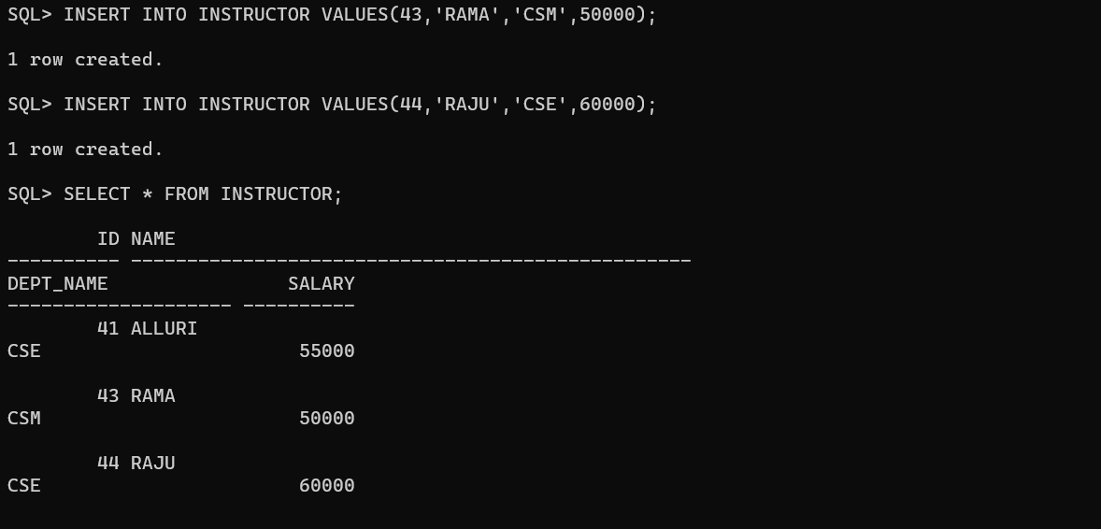

**AN EXAMPLE TO CREATE TRIGGER:**

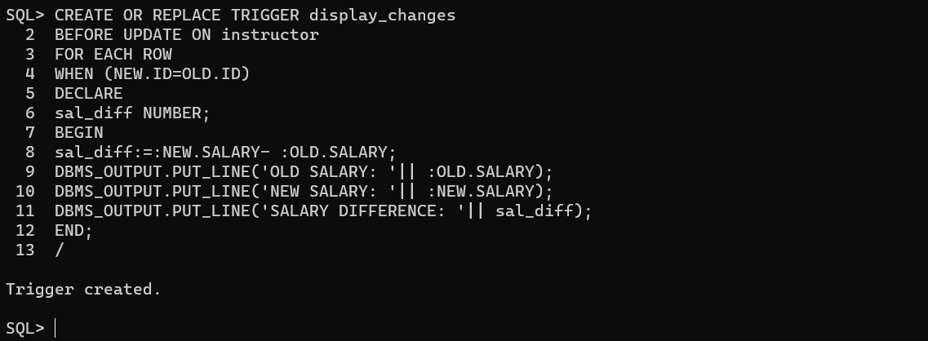

**A PL/SQL Procedure to execute a trigger:**

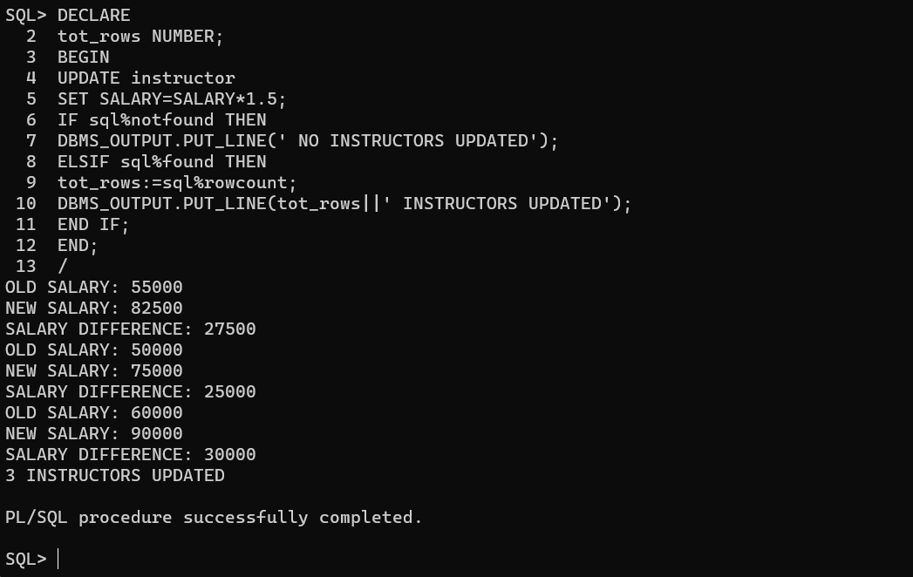

**Conclusion:** In this lab, we have practiced a PL/SQL program to implement Trigger on table.

**EXPERIMENT-16**

**AIM:** To write a PL/SQL program to implement Cursor on table.

**CREATING A TABLE:**

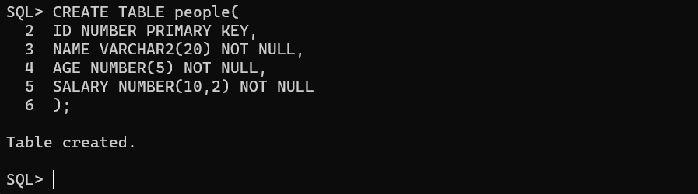

**INSERTING VALUES INTO TABLE:**

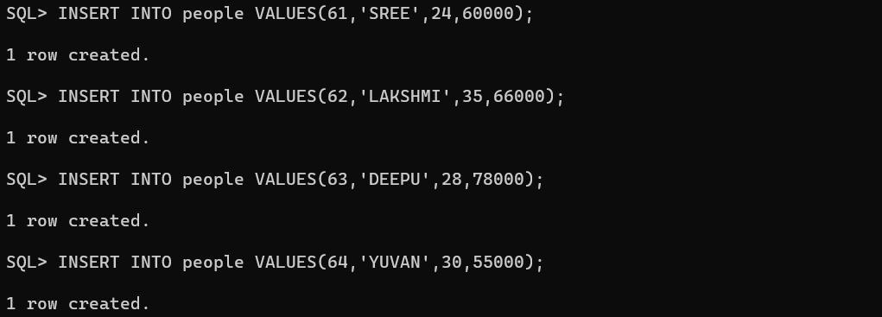

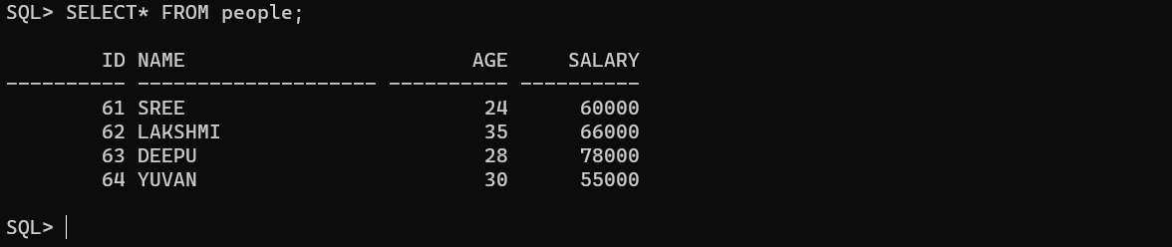

**CREATE UPDATE PROCEDURE:**

**CREATE PROCEDURE:**

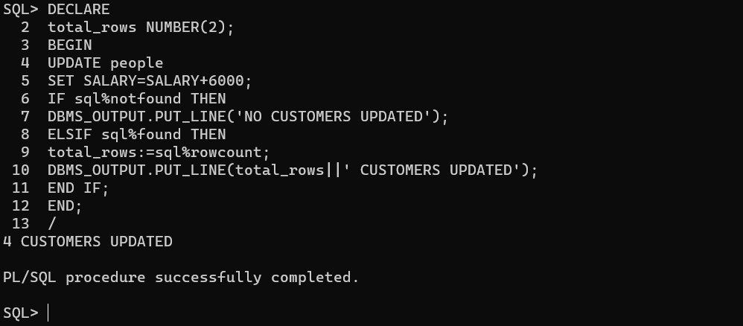

**PL/SQL Program using Explicit Cursors:**

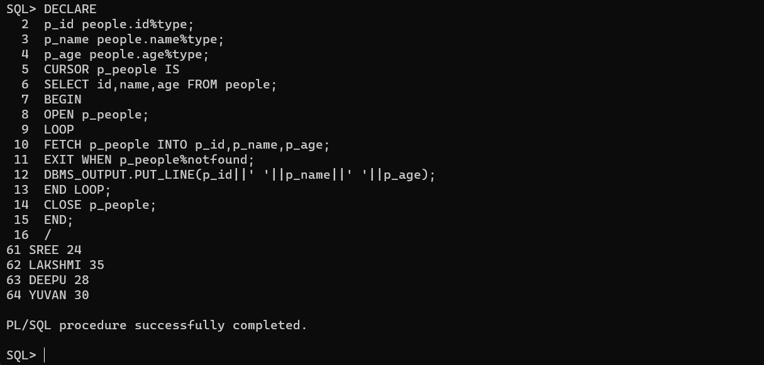

**Conclusion:** In this lab, we have practiced a PL/SQL program to implement Cursor on table.